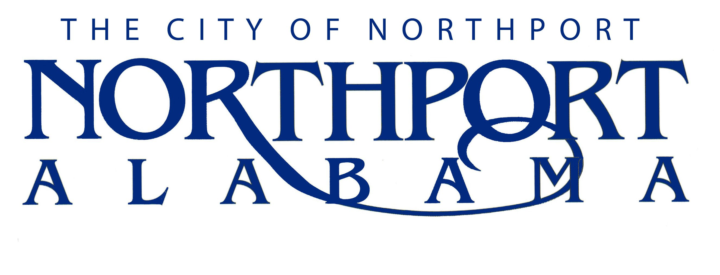

Water Utility Crew Chief

Summary

Under direction, performs semi-skilled work and directs work of others in the installation, construction and maintenance of water distribution mains and appurtenances. Gives direction to employees of a lower classification assigned to him/her for specific assignments.

Duties and Responsibilities

- Repair, Construction, and Maintenance (60%)
- Assists and directs subordinates in the installation, construction, repair, and maintenance of water mains, water services, water meters and boxes, hydrants, gate, check, and air release valves, concrete thrust blocks, tees, bends, and other water system appurtenances.

- Water Service Installation (20%)
- Installs water services of various sizes; Including service taps using tapping machines, service lines using various materials such as plastic, copper, etc. and water meters and boxes.

- Investigation (10%)
- Investigates water service complaints and reports the findings to superintendent.

- Utility Locates (10%)
- Performs underground Utility locates.

- Subject to overtime and afterhours call-outs due to repairs, maintenance, or other projects.

- Performs other reasonably related duties in a safe manner as assigned by immediate supervisor and other supervisors as required.

Job Specifications

Qualifications:

- Must have an educational level equivalent to high school diploma.

- Must have experience in the construction, maintenance and repair of water mains and appurtenances.

- Must have at least a valid Class A Commercial Driver’s License or be able to obtain a Class A Commercial Driver’s License within 4 months of hire and have an acceptable driving record.

- Must possess an Alabama Grade I Water certification or be able to pass the certification exam within 12 months of hire, depending on the ADEM testing schedule.

- Must maintain regular attendance on the job.

Knowledge, Skills, and Abilities:

- Knowledge of traffic laws, ordinances and rules involved in the operation of motor vehicles.

- Considerable knowledge of the various materials, methods and practices and equipment used in the construction, maintenance and repair of water and sewer systems including: installation of galvanized, copper, ductile iron, PVC and cast iron water mains and appurtenances; vitrified clay, PVC, and ductile iron sanitary sewers, service laterals, manholes; ductile iron and PVC force mains, associated valves and concrete thrust blocking; and other related appurtenances.

- Knowledge of occupational hazards and applicable safety precautions in general construction and maintenance operations particularly as these requirements relate to work around construction equipment, trench excavations and traffic control around the work site (flagmen, signs, barricades and cones, etc.).

- Considerable knowledge of the geography and street locations of the City of Northport and surrounding areas.

- Ability to read and write legibly.

- Ability to make simple mathematical calculations rapidly and accurately.

- Possess mechanical abilities sufficient to meet the requirements of the job.

- Ability to diagnose plumbing defects.

- Ability to accomplish the work assigned in a neat, efficient manner.

- Ability to maintain an effective and harmonious working relationship with other employees and citizens.

- Ability to operate various types of equipment normally used in construction of Public Works projects, particularly those associated with water systems including concrete and pipe saws, taping machines, mechanical tamps, etc.

- Ability to maintain an effective working relationship with other employees.

- Must be able to work on-call and overtime as necessary.

Physical Characteristics:

- Strength to perform heavy manual labor.

- See well enough to read text material, tables, blue prints and troubleshooting guides.

- Hear well enough to comprehend oral instructions in person and over the telephone/radio.

- Have ability to move objects weighing no more than 100 pounds.

- Have body mobility to move in and about confined spaces and rough terrain.

- Ability to work in various types of weather.

