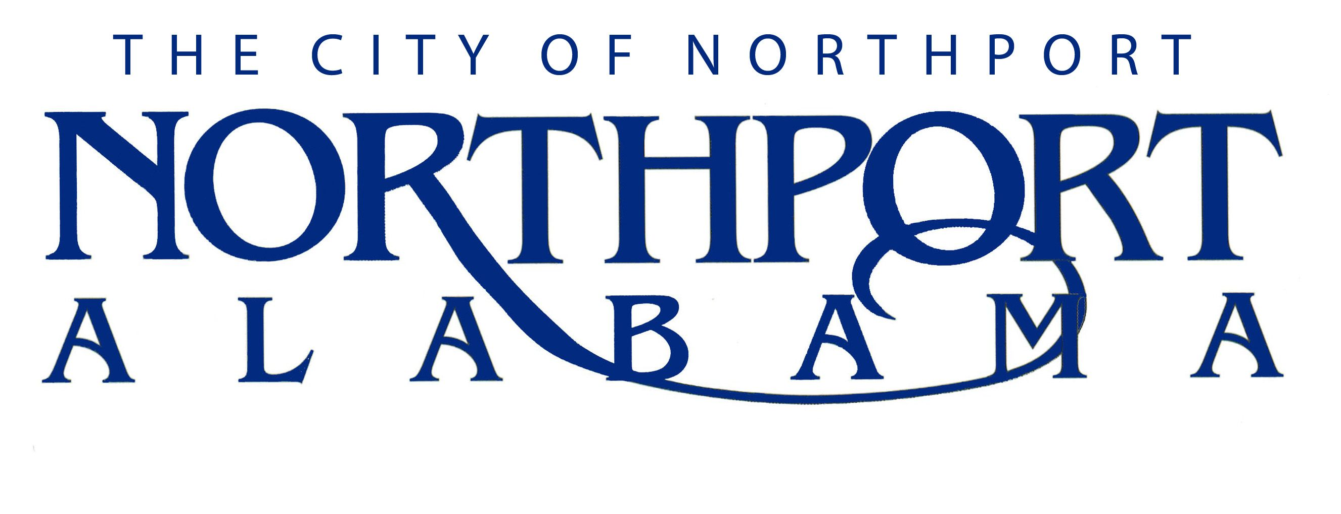

UTILITY CREW CHIEF-WASTEWATER

Summary

Under direction, performs craft level work in the installation, construction and maintenance of wastewater collection lines, and pump station appurtenances. Gives direction to employees of a lower classification assigned to him/her for execution of assignments.

DUTIES AND RESPONSIBILITIES

A. Assistance (70%)

- Assists and directs the construction, installation and maintenance of sewer mains, manholes, force mains, pump stations and other wastewater system appurtenances.

B. Investigation (20%)

- Investigates wastewater service complaints and reports findings to Supervisor.

C. Performs other reasonably related duties in a safe manner as assigned by immediate supervisor and other supervisors.

JOB SPECIFICATIONS

Qualifications:

- Must have an educational level equivalent to high school diploma.

- Must have experience in the upkeep and operation of wastewater collection systems.

- Must have at least a valid Class B Commercial Driver’s License and have an acceptable driving record.

- Must possess an Alabama Class Ic Wastewater certification or be able to pass the certification exam within a 12 month period, depending on the ADEM testing schedule.

- Must maintain regular attendance on the job.

Knowledge, Skills, and Abilities:

- Knowledge of traffic laws, ordinances and rules involved in the operation of motor vehicles.

- Considerable knowledge of the various materials, methods and practices and equipment used in the construction, maintenance and repair of water and sewer systems including: installation of galvanized, copper, ductile iron, PVC and cast iron water mains and appurtenances; vitrified clay, PVC, and ductile iron sanitary sewers, service laterals, manholes; ductile iron and PVC force mains, associated valves and concrete thrust blocking; and other related appurtenances.

- Knowledge of the materials normally used and suitable for pipe cushion (bedding) and back fill; placement and compaction requirements.

- Knowledge of the need, proper location and construction of thrust blocking, manholes and service laterals.

- Knowledge and understanding of survey stations, levels, elevations, grades and slopes.

- Knowledge of occupational hazards and applicable safety precautions in general construction and maintenance operations particularly as these requirements relate to work around construction equipment, trench excavations and traffic control around the work site (flagmen, signs, barricades and cones, etc.).

- Knowledge of pressure head, friction loss and calculation of same.

- Ability to meet the mechanical abilities of the job.

- Ability to use the technical terms normally associated with the construction and maintenance of utility projects such as cover, bedding, grade or slope, invert, lateral, survey stationing; etc

- Ability to operate various types of equipment normally used in construction of underground utility projects including pipe and concrete saws, mechanical tamps, etc.

- * Ability to use the sewer jet, water tanker truck and water service tapping machine.

- Ability to read and interpret civil engineering construction drawings.

- Ability to estimate the time, materials and equipment needed to accomplish an assigned task.

- Ability to accomplish the work assigned in an efficient, neat and workmanlike manner.

- Ability to maintain an effective working relationship with other employees.

- Must be able to work on-call and overtime as necessary.

Physical Characteristics:

- Strength to perform heavy manual labor.

- See well enough to read text material, tables, blue prints and troubleshooting guides.

- Hear well enough to comprehend oral instructions in person and over the telephone/radio.

- Have ability to move objects weighing no more than 100 pounds.

- Have body mobility to move in and about confined spaces and rough terrain.

- Ability to work in various types of weather.

*May be learned on the job.

